**K OMEGA**

**Y+ =1**

**y=0.123mm(Inflation First Layer Thickness)**

**Design Modular (3 Faces)**

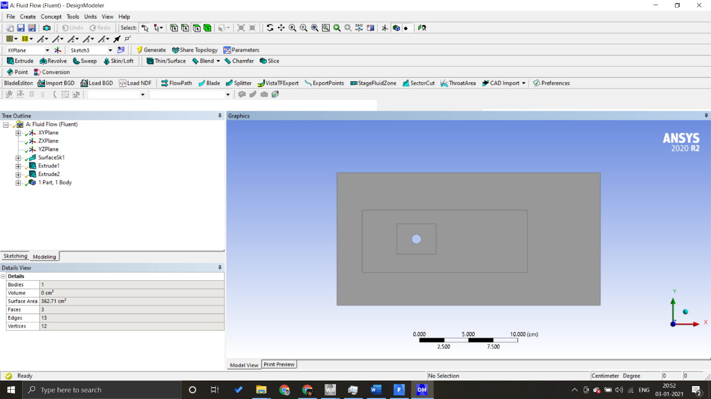

**MESHING**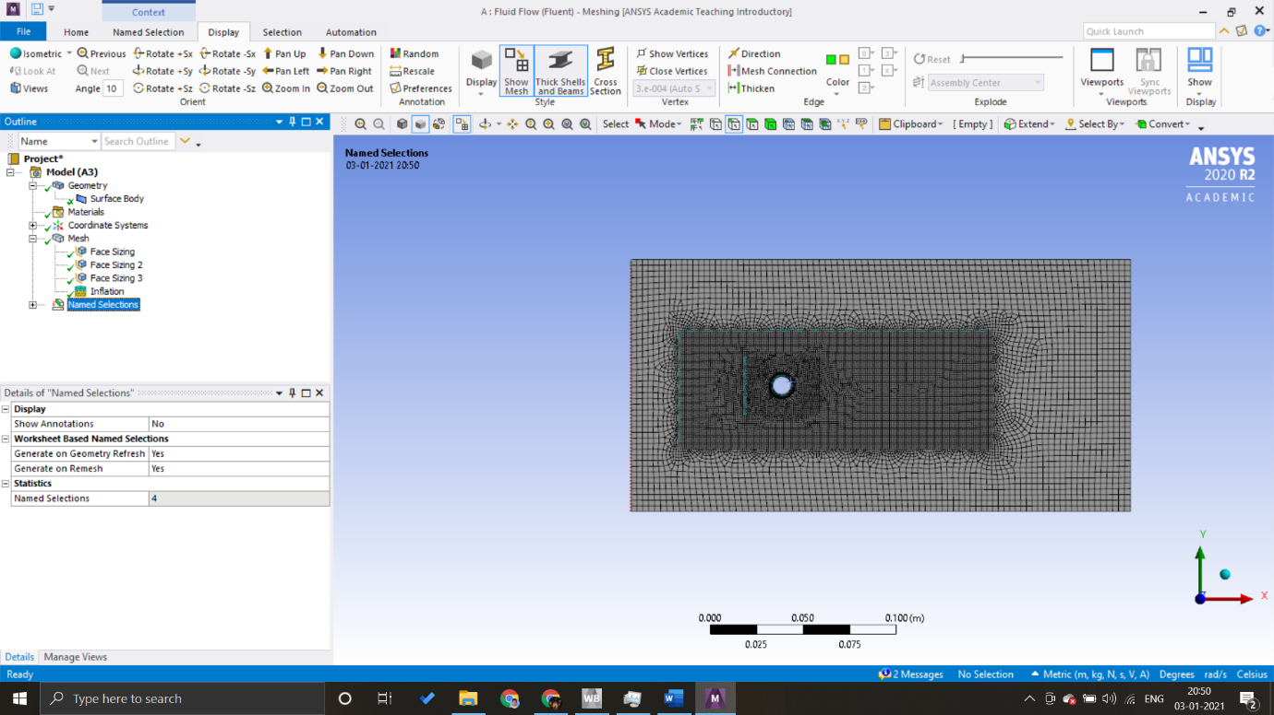

**Scaled Residuals**

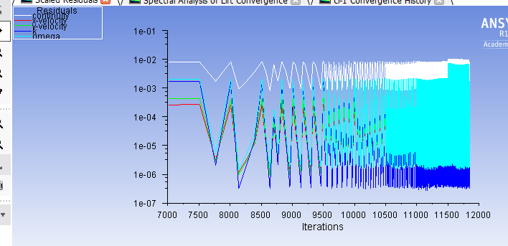

**Static Pressure**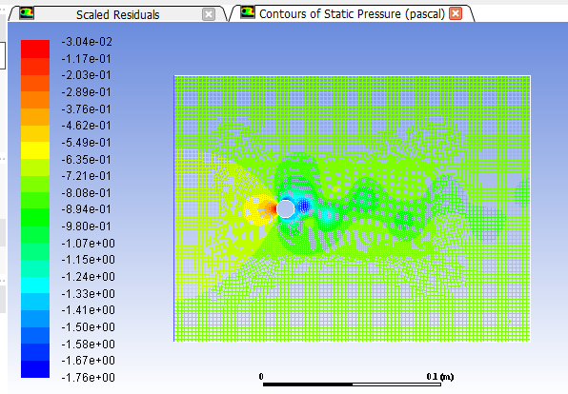

**Dissipation Rate(Omega)**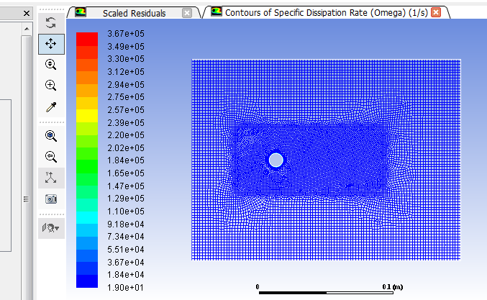

**Contour Of Total Pressure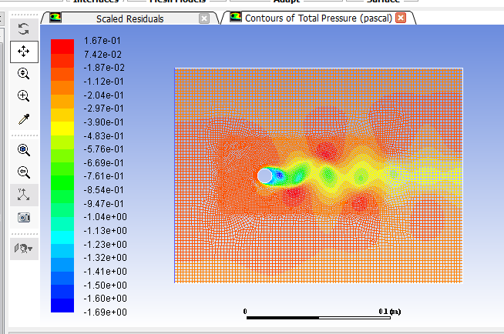Contour Of turbulent Dissipation Rate (Epsilon)**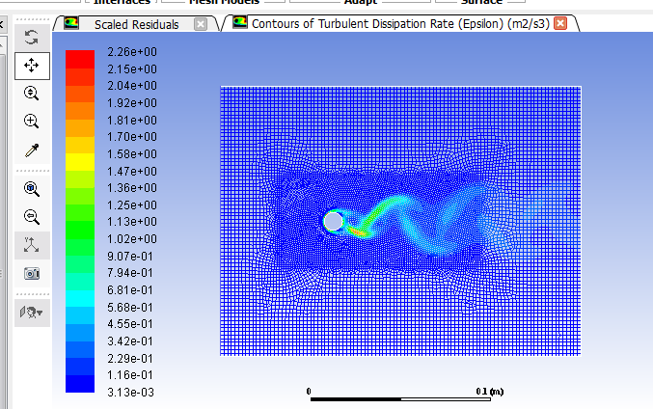

**Contours of Turbulent Kinetic Energy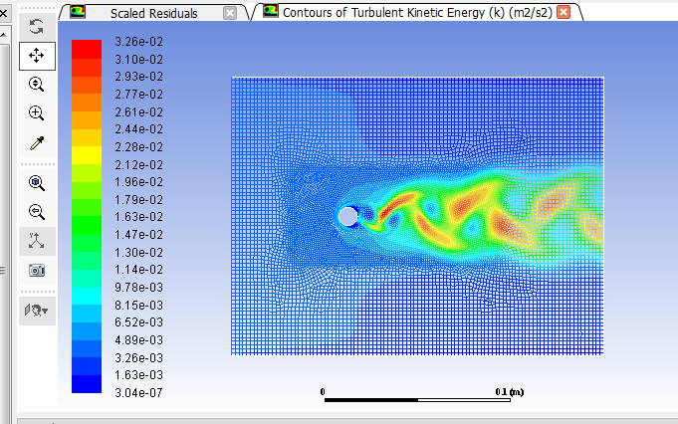\**

**Cd Drag Plot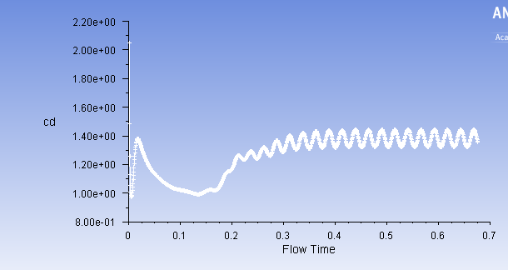Contour Of Velocity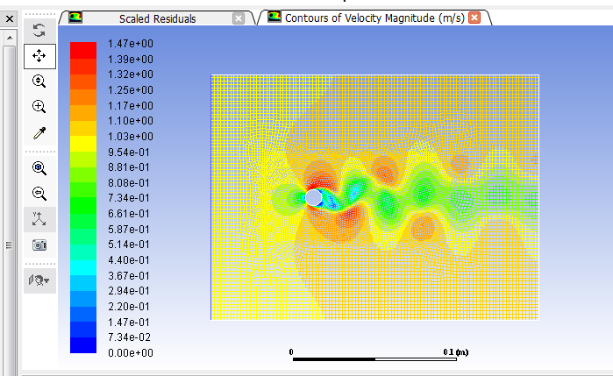Contour Of Y plus**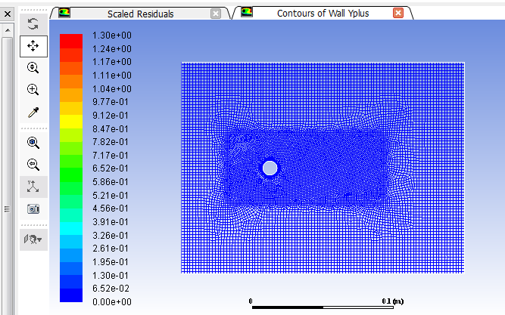

**I performed a fft of the sorted Cl values in matlab and found out Frequency n=18.57**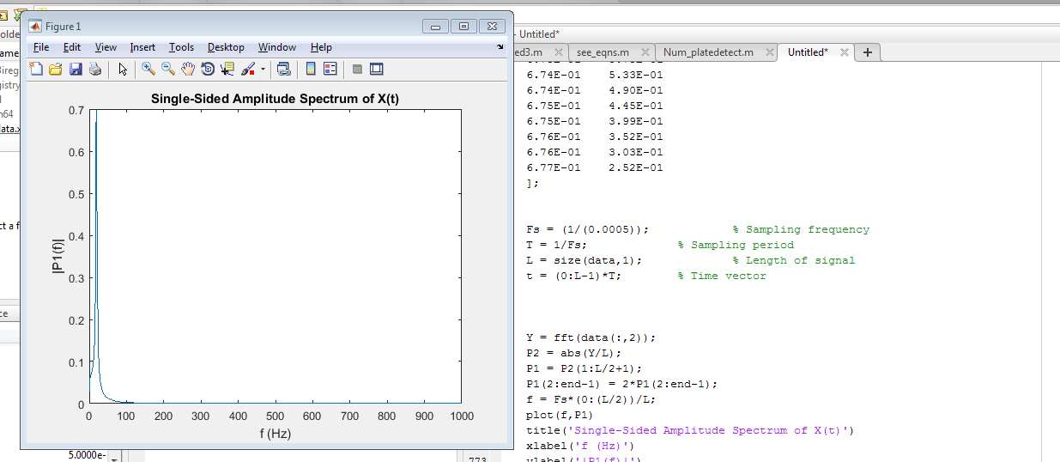

**N=18.57**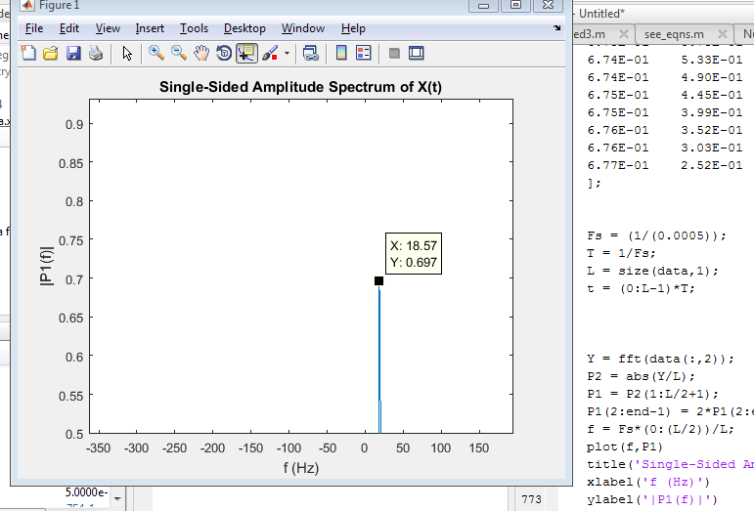

**Sorted Out CL values (Plot of Cl)**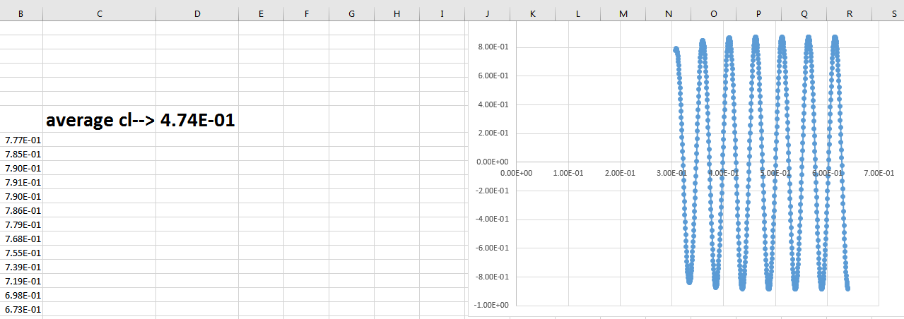

**Cl vs time Plot**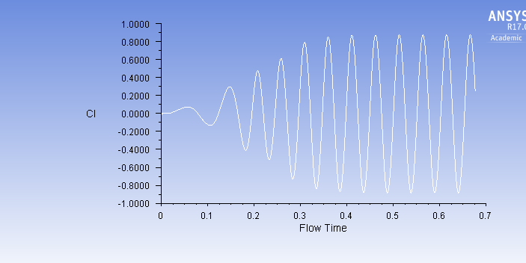

**CD AVERAGE SORTED OUT DATA:**

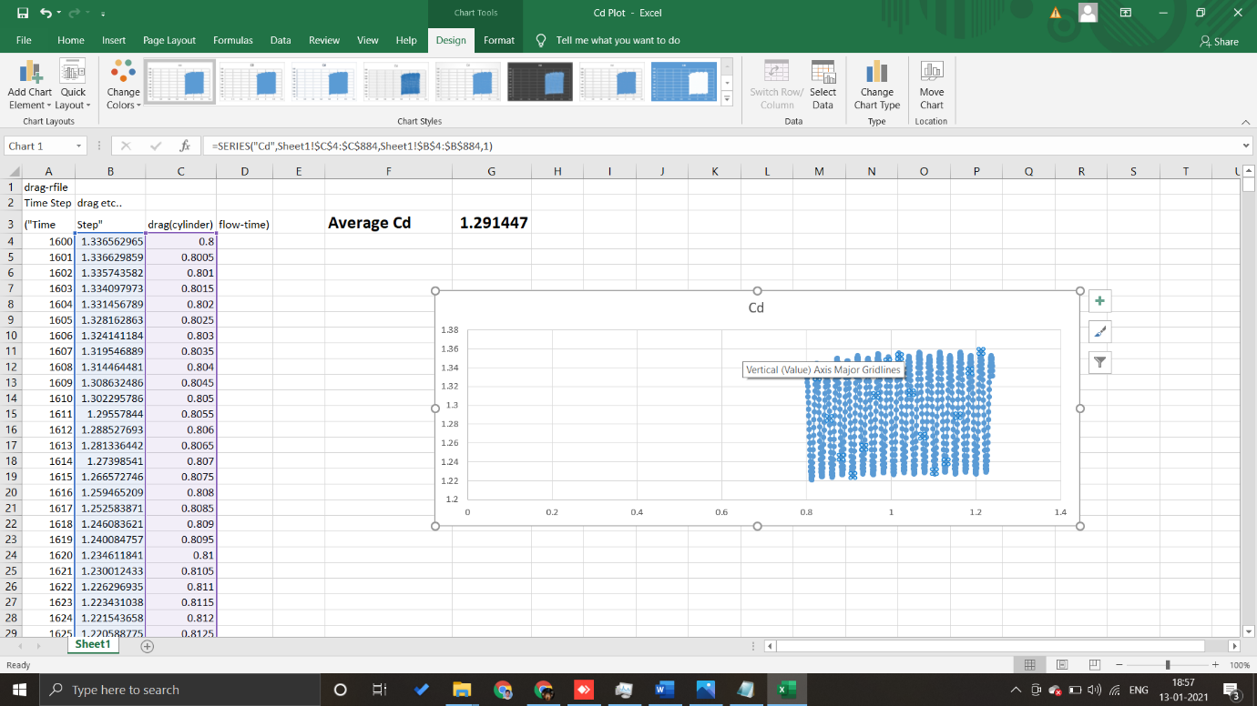

**CONCLUSIONS:**

🡪St(strouhal number) =Frequency * Diameter/ Velocity

= 18.57*0.01/1

=0.1857

🡪Average Cl Value(Of sorted data)=0.474(UPWARD)

🡪Average Cd Value(Of sorted data)=1.291447